**Assignment 35.1**

**Problem Statement:**

● Create a employee table in Mysql and columns as Emp_id, Emp_name, Dept_name(Hadoop Developer), Emp_sal.

● Import the employee table contents into the HDFS directory using Sqoop.

● Create a employee2 table in Mysql and Export Top 5 employee details Emp_name and Emp_sal from HDFS directory to Mysql table employee2 using Sqoop.

● Explain the procedures performed, Share the screenshots of commands and results for the same.

Creating a table named Employee and inserting the values using insert command.

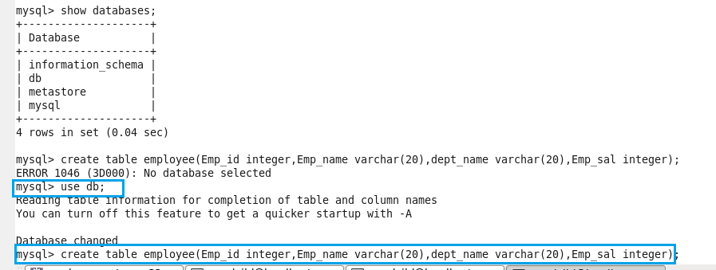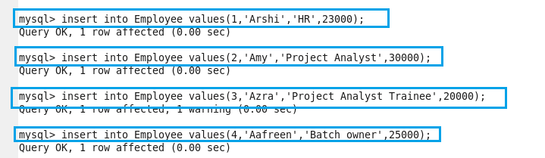

Performing basic select operation to display the contents of the table

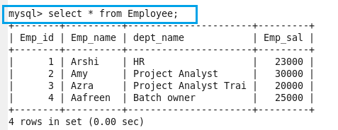

**Importing the data from mysql to hdfs using the below command**

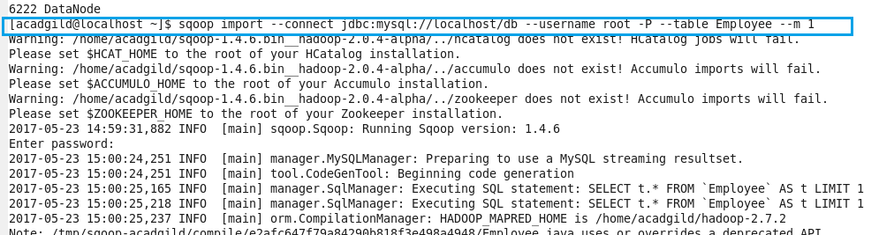

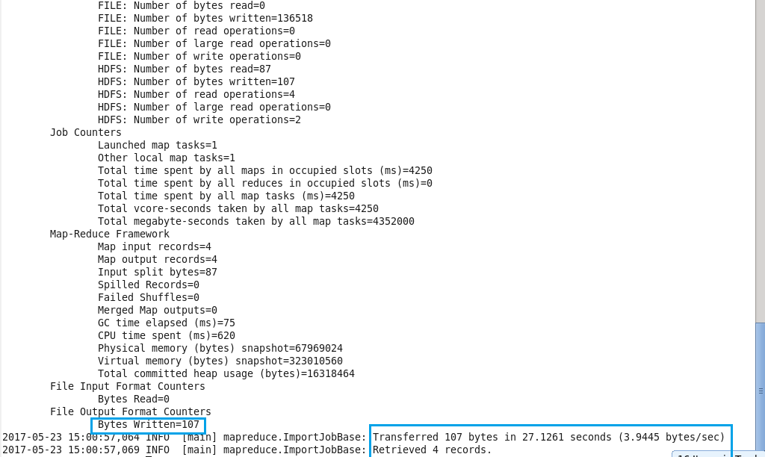

Here we can see that the data is imported successfully to hdfs.

**Checking whether the files are imported and displaying the contents of the Employee:**

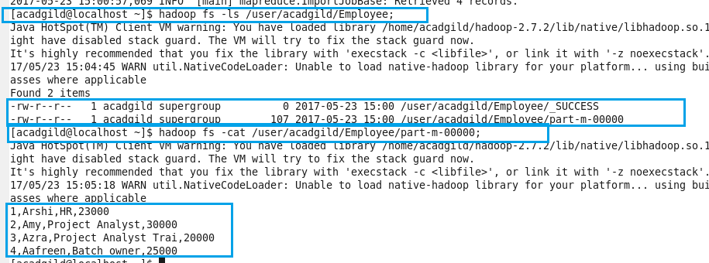

**Again creating the new table as Employee1 and no data is inserting into it so as to export it from hdfs to mysql:**

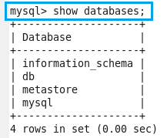

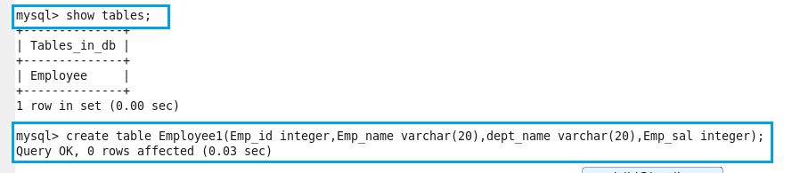

Here we can see that there is no data present in the table Employee1

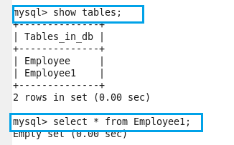

**Exporting the table from hdfs to mysql:**

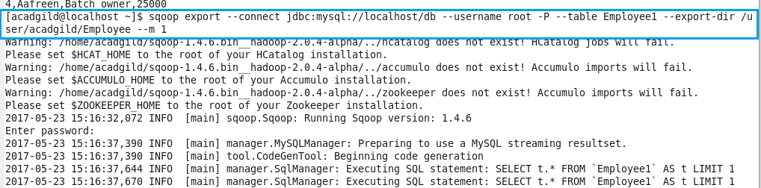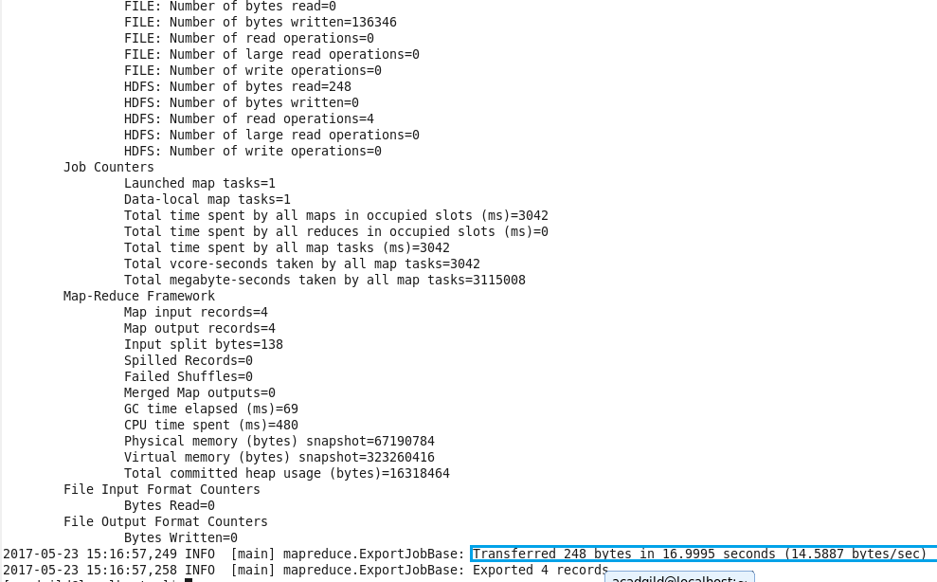

Here we can see that the data is successfully exported.

Now, showing the exported table

